CASE STUDIES

Name: MUDDANAGIRI DURGA SAI MANASA

Roll.No: 2520030500

Section: 1[Practical]

Task 1: Create and Manage Files
Objective: Practice creating, listing, viewing, and deleting files.

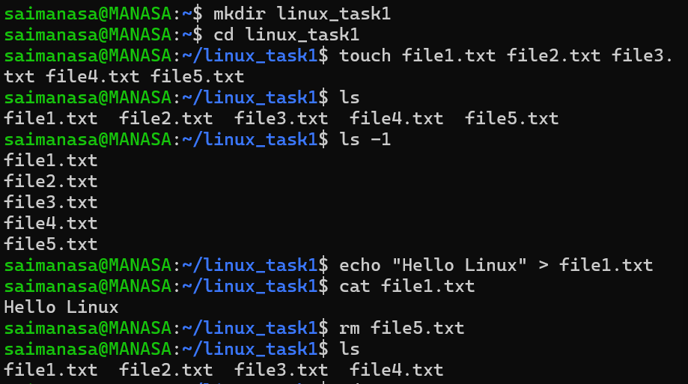

Task 2: Copy and Move Files
Objective: Practice copying and moving files and directories.

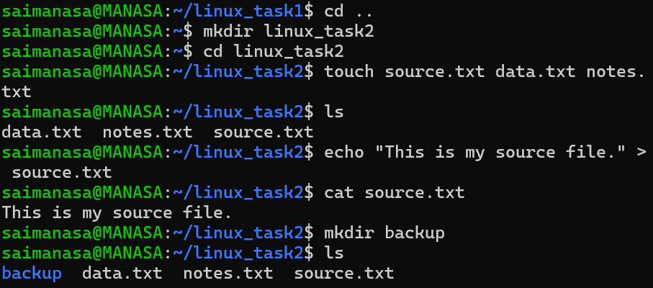

Task 3: Working with head and tail
Objective: Practice viewing specific portions of a file.

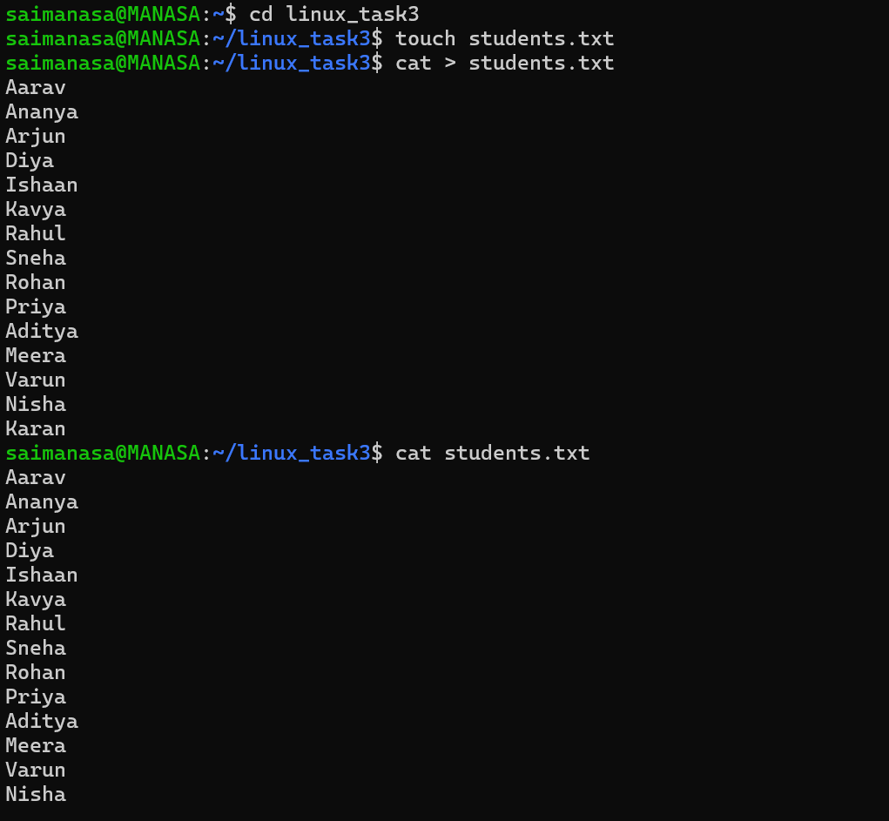

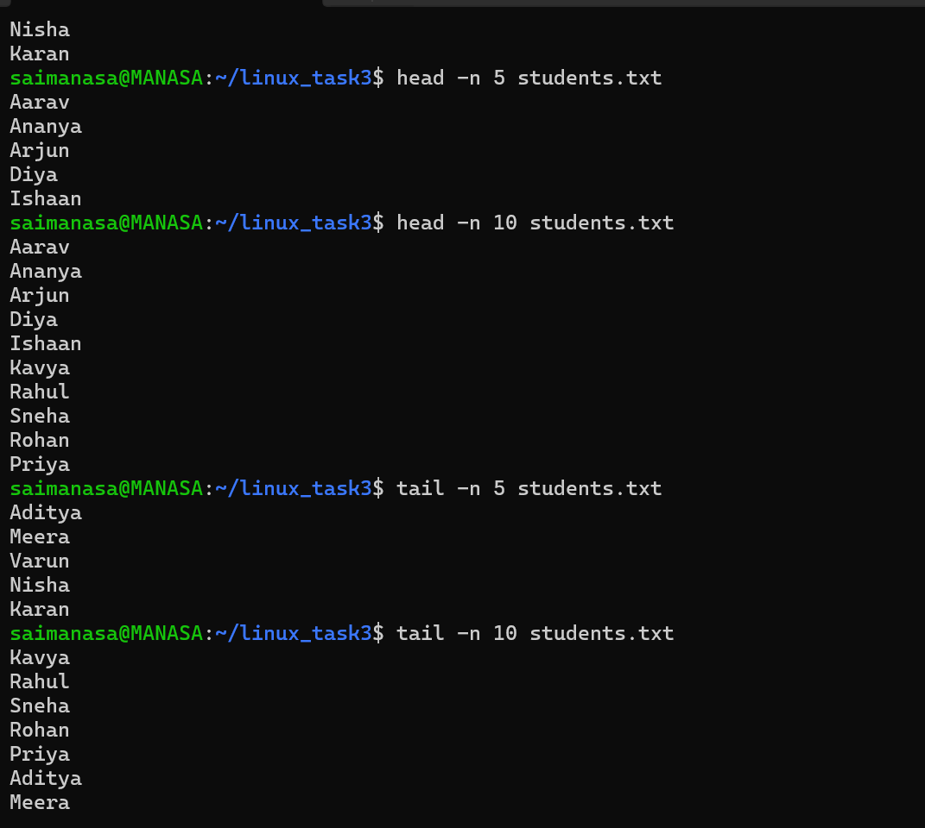

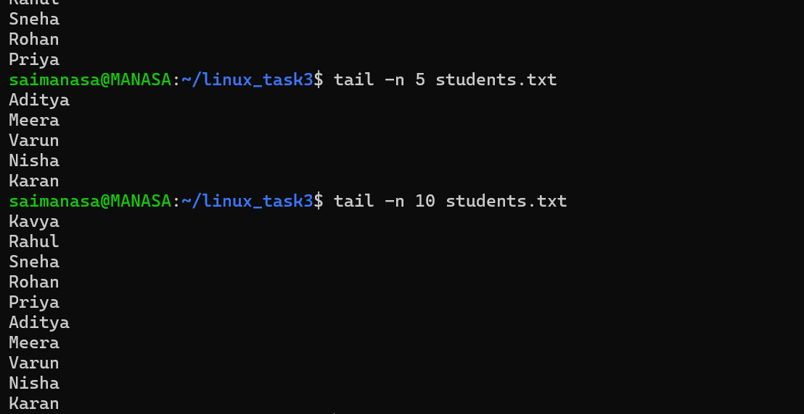

Task 4: Organize Files
Objective: Organize files into different directories using mv.

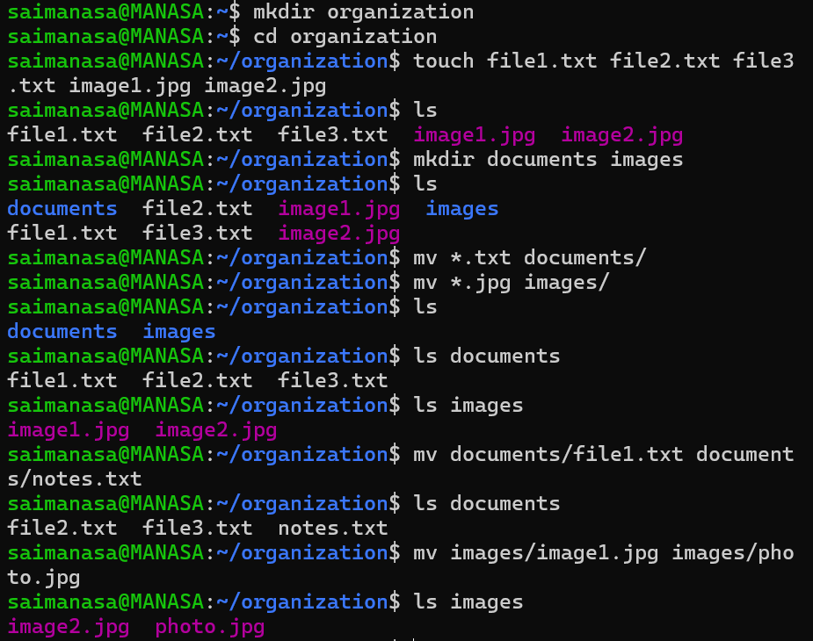

Task 5: Directory Management
Objective: Practice creating nested directories and removing them.

